DATABASE ASSIGNMENT
Enterprise Database Design, Implementation & Web Integration
Case Study: MaxMart Supermarket — Accra, Ghana
GROUP MEMBERS
Donkor Shepherd Mensah 2425404178
Katumi Amadu 2425401702
Agyapong Epaphras Daleku Mawufemor 2425401280
Jason Amoah Nyarko 2425402719
Cornelius Tetteh Tetteh 2425400662
Dennis Adu Denkyira 2425403696
Kweku Nyamekye Sarfo-Mensah 2425401408
Nana Yaa Serwaa Acheampong 2425401435

Table of Contents
Table of Contents 1
Phase 1 — Business Requirements Specification 1
1.1 Company Profile 1
1.2 Narrative of System Requirements 1
1.3 Key Business Rules 1
Phase 2 — Entity Types & Attribute Identification 1
Phase 3 — Data Integrity and Constraints 1
Phase 4 — Entity Type Schema Diagram 1
Phase 5 — Conceptual Modelling — Entity-Relationship Diagram 1
5.1 Relationships, Cardinality & Participation Constraints 1
Phase 6 — Logical Relational Schema Diagram 1
6.1 Referential Integrity Summary 1
Phase 7 — Physical Database Implementation & Population 1
7.1 Data Definition Language (DDL) — schema.sql 1
7.2 Data Manipulation Language (DML) — seed.sql 1
Phase 8 — Web Interface Integration 1
8.1 Architecture Overview 1
8.2 Authentication & Sessions 1
8.3 Frontend Application Shell 1
8.4 CRUD & Business-Process Mapping 1
8.5 Delete-Safety Behaviour 1
8.6 Checkout / Point-of-Sale Flow 1
8.7 Live Dashboard Screenshots 1
8.8 Security & Improvement Notes 1
Conclusion 1
Appendix A — Full Backend Source (api.php) 1
Appendix B — Full Frontend Source (index.html) 1

Phase 1 — Business Requirements Specification

1.1 Company Profile
MaxMart Supermarket is a mid-sized, independently owned grocery retailer trading from a single storefront in Accra, Ghana. The store stocks a mix of imported packaged goods — dairy, bakery, and beverage lines — alongside locally sourced staples such as rice, banku mix, and kenkey, serving households in the surrounding neighbourhood. MaxMart currently employs a small team split across two roles: a store Manager who oversees pricing, stock, and supplier relationships, and Cashiers who process sales at the till.
As the business has grown beyond a handful of shelves, its owner has found that tracking stock levels, supplier relationships, and daily sales on paper ledgers and spreadsheets is no longer reliable — prices drift out of sync between the shelf and the till, low stock is not caught before a line runs out, and there is no single source of truth a Manager can query at the end of a trading day. MaxMart has therefore commissioned a relational database, backed by a simple internal web dashboard, so staff can view and update the product catalogue directly instead of editing spreadsheets by hand.

1.2 Narrative of System Requirements
Consultation with the store owner identified the following operational needs the system must support:
- Staff accounts — every employee who can access the system must be uniquely identifiable, assigned exactly one role (Manager or Cashier), and authenticated with a securely hashed password.
- Category management — every product sold must be grouped into a functional category (e.g. Dairy, Bakery, Beverages) so the Manager can review performance and shelf allocation by department.
- Supplier tracking — the business deals with multiple external suppliers and needs a record of each supplier's contact details, independent of which products they currently provide.
- Product catalogue — each product needs a unique SKU/barcode, a display name, a category, an optional supplier, a unit price, an on-hand stock count, and a reorder threshold.
- Sales recording — each completed sale must be captured as an order tied to the staff member who processed it, with individual line items recording the product sold, the quantity, and the price charged at the time of sale, so historical revenue figures stay accurate even if the catalogue price changes afterwards.
- Operational reporting — the Manager should be able to see, at a glance, how many distinct products are carried and the total number of units on hand, to plan reordering and shelf space.

1.3 Key Business Rules
The following business rules govern the integrity of MaxMart's data and are enforced directly at the database layer wherever possible, rather than relying on the application code alone:
- Every product must belong to exactly one category; a category cannot be removed while products still reference it.
- A supplier may be removed from the system without deleting the products they supply — those products simply become unassigned.
- No product may carry a negative price or a negative stock quantity, and no order line item may carry a negative quantity or unit price.
- SKUs, category names, and staff email addresses must each be unique across the system.
- A staff record cannot be deleted while it still has orders attached, preserving the audit trail of who processed each historical sale.
- Deleting an order deletes its line items with it, since a line item has no independent meaning once its parent order is gone.
- A product cannot be deleted while it appears in historical order line items, protecting past sales records from silently losing their meaning.
- Every staff member is assigned one of exactly two roles — Manager or Cashier — enforced by a domain check constraint.

Phase 2 — Entity Types & Attribute Identification
Based on the requirements narrative above, six entity types were identified. At this stage attributes are listed by name only, ahead of the technical typing and constraint definition carried out in Phase 3.
Entity Type | Attributes Identified
STAFF | staff_id, first_name, last_name, email, password_hash, role, created_at
CATEGORIES | category_id, category_name, description
SUPPLIERS | supplier_id, company_name, contact_name, phone
PRODUCTS | product_id, sku, product_name, category_id, supplier_id, price, stock_quantity, reorder_level
ORDERS | order_id, staff_id, order_date, total_amount
ORDER_ITEMS | order_item_id, order_id, product_id, quantity, unit_price

ORDER_ITEMS is an associative (bridge) entity: it resolves the many-to-many relationship between a single order and the many products it can contain, while also carrying its own attributes (quantity, unit_price) that belong to the association itself rather than to either parent entity.

Phase 3 — Data Integrity and Constraints
Every attribute identified in Phase 2 is given an explicit data type and constraint set below, exactly as implemented in the physical schema (see Phase 7).

STAFF
Attribute | Data Type | PK/FK | Null? | Additional Constraints
staff_id | INT | PK | NOT NULL | AUTO_INCREMENT
first_name | VARCHAR(50) | — | NOT NULL | —
last_name | VARCHAR(50) | — | NOT NULL | —
email | VARCHAR(100) | — | NOT NULL | UNIQUE
password_hash | VARCHAR(255) | — | NOT NULL | Stores a bcrypt hash, never plaintext
role | VARCHAR(20) | — | NOT NULL | CHECK (role IN ('Manager','Cashier'))
created_at | TIMESTAMP | — | NOT NULL | DEFAULT CURRENT_TIMESTAMP

CATEGORIES
Attribute | Data Type | PK/FK | Null? | Additional Constraints
category_id | INT | PK | NOT NULL | AUTO_INCREMENT
category_name | VARCHAR(50) | — | NOT NULL | UNIQUE
description | TEXT | — | NULL | —

SUPPLIERS
Attribute | Data Type | PK/FK | Null? | Additional Constraints
supplier_id | INT | PK | NOT NULL | AUTO_INCREMENT
company_name | VARCHAR(100) | — | NOT NULL | —
contact_name | VARCHAR(50) | — | NULL | —
phone | VARCHAR(20) | — | NOT NULL | —

PRODUCTS
Attribute | Data Type | PK/FK | Null? | Additional Constraints
product_id | INT | PK | NOT NULL | AUTO_INCREMENT
sku | VARCHAR(50) | — | NOT NULL | UNIQUE
product_name | VARCHAR(100) | — | NOT NULL | —
category_id | INT | FK | NOT NULL | REFERENCES categories(category_id) ON DELETE RESTRICT
supplier_id | INT | FK | NULL | REFERENCES suppliers(supplier_id) ON DELETE SET NULL
price | DECIMAL(10,2) | — | NOT NULL | CHECK (price >= 0.00)
stock_quantity | INT | — | NOT NULL | DEFAULT 0, CHECK (stock_quantity >= 0)
reorder_level | INT | — | NOT NULL | DEFAULT 10

ORDERS
Attribute | Data Type | PK/FK | Null? | Additional Constraints
order_id | INT | PK | NOT NULL | AUTO_INCREMENT
staff_id | INT | FK | NOT NULL | REFERENCES staff(staff_id) ON DELETE RESTRICT
order_date | DATETIME | — | NOT NULL | DEFAULT CURRENT_TIMESTAMP
total_amount | DECIMAL(10,2) | — | NOT NULL | DEFAULT 0.00, CHECK (total_amount >= 0.00)

ORDER_ITEMS
Attribute | Data Type | PK/FK | Null? | Additional Constraints
order_item_id | INT | PK | NOT NULL | AUTO_INCREMENT
order_id | INT | FK | NOT NULL | REFERENCES orders(order_id) ON DELETE CASCADE
product_id | INT | FK | NOT NULL | REFERENCES products(product_id) ON DELETE RESTRICT
quantity | INT | — | NOT NULL | CHECK (quantity > 0)
unit_price | DECIMAL(10,2) | — | NOT NULL | CHECK (unit_price >= 0.00)

Phase 4 — Entity Type Schema Diagram
The diagram below shows the six entity types identified in Phase 2 as isolated structures, before any relationships are drawn between them — each box lists an entity's own attributes only.
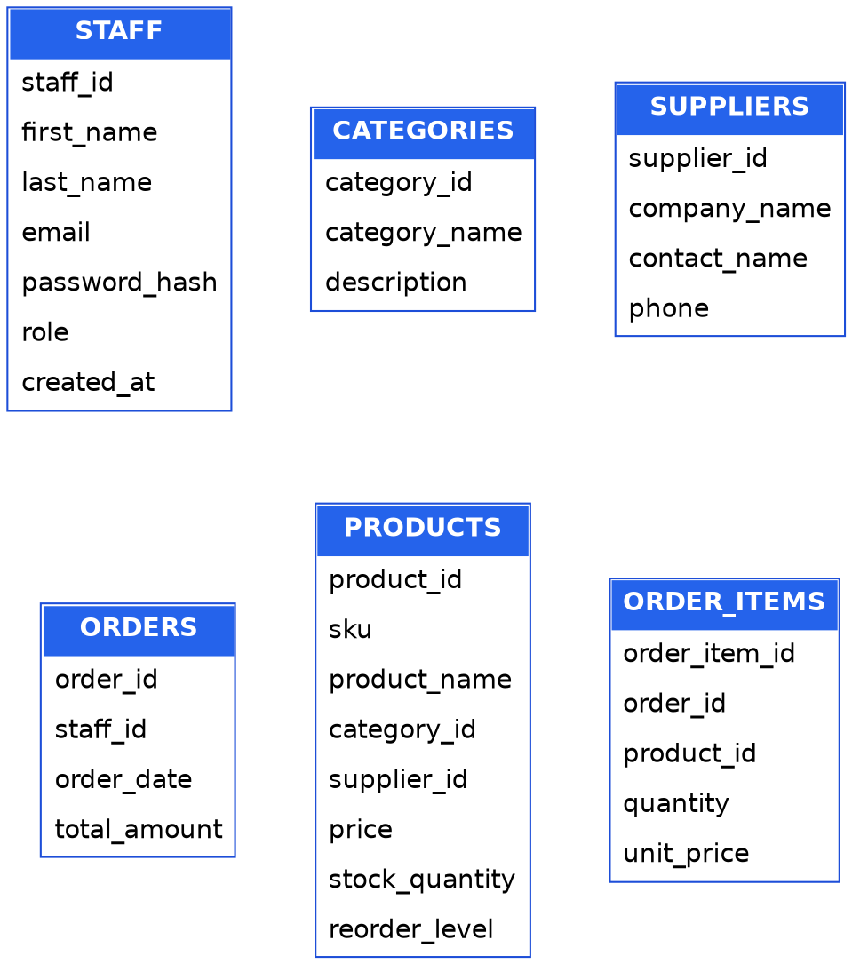
Figure 1 — Isolated entity types with their attributes, prior to relationship modelling.

Phase 5 — Conceptual Modelling — Entity-Relationship Diagram
The Entity-Relationship diagram below (Chen notation) connects the six entities via five relationships, with cardinality (1 or M) marked on each connecting line.
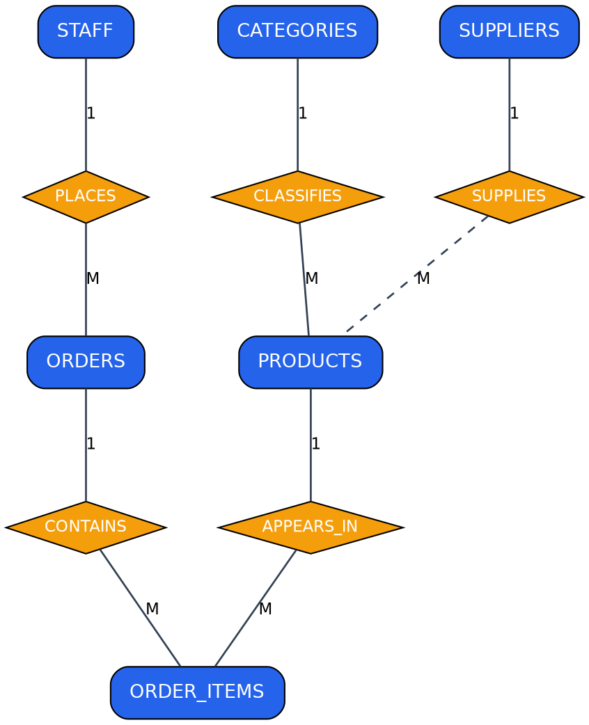
Figure 2 — Conceptual ER diagram showing entities (rectangles), relationships (diamonds), and cardinalities.

5.1 Relationships, Cardinality & Participation Constraints
Relationship | Entities Involved | Cardinality | Left Participation | Right Participation
Places | STAFF → ORDERS | 1 : M | Partial | Total
Contains | ORDERS → ORDER_ITEMS | 1 : M | Partial | Total
Appears In | PRODUCTS → ORDER_ITEMS | 1 : M | Partial | Total
Classifies | CATEGORIES → PRODUCTS | 1 : M | Partial | Total
Supplies | SUPPLIERS → PRODUCTS | 1 : M (optional) | Partial | Partial

"Total" participation means every instance of that entity must take part in the relationship (e.g. every order must have been placed by a staff member — staff_id is NOT NULL). "Partial" participation means an instance may legitimately exist without taking part (e.g. a staff member may not yet have processed any order, and — because supplier_id is nullable — a product may exist with no linked supplier).

Phase 6 — Logical Relational Schema Diagram
The conceptual ER model was translated into a logical relational schema. Each entity became a table; primary keys are underlined and foreign keys are italicised. Arrows use crow's-foot notation, running from the many (crow's-foot) side to the one (single tick) side, to show referential integrity between foreign keys and the primary keys they reference.
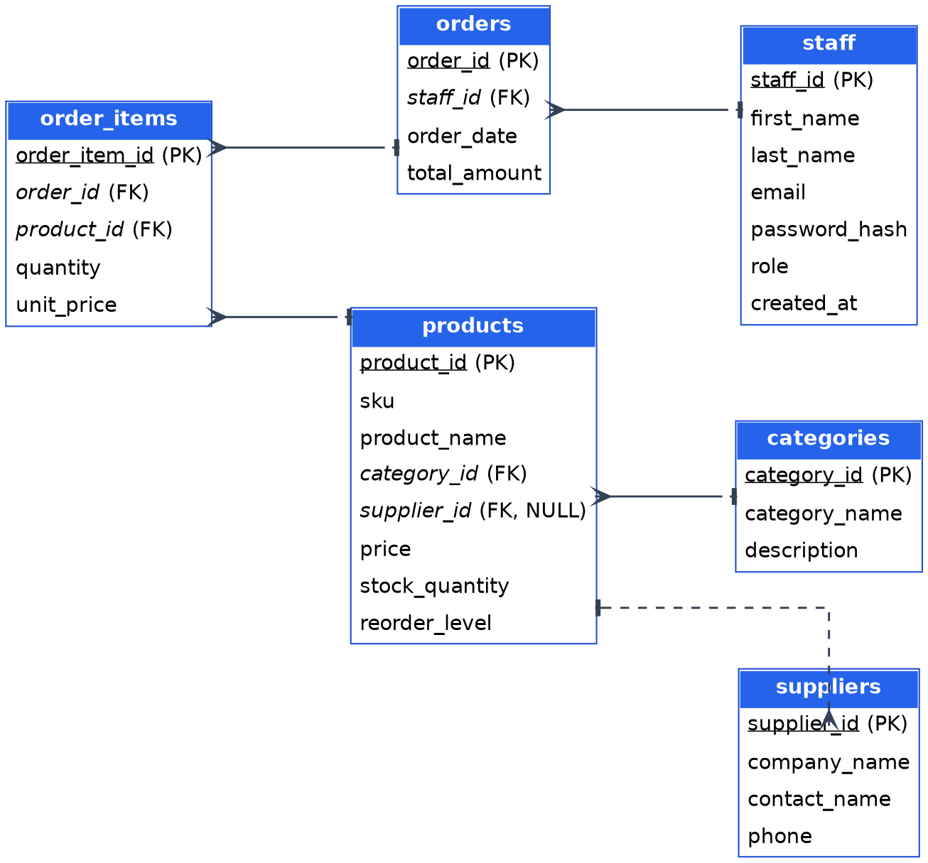
Figure 3 — Logical relational schema with primary/foreign keys and referential integrity arrows.

6.1 Referential Integrity Summary
Foreign Key | Child Table | Parent Table | On Delete | Rationale
category_id | products | categories | RESTRICT | Prevents orphaned products if a category still in use is removed.
supplier_id | products | suppliers | SET NULL | Lets a supplier relationship end without deleting the product.
staff_id | orders | staff | RESTRICT | Preserves the audit trail of who processed historical sales.
order_id | order_items | orders | CASCADE | A line item has no meaning once its parent order is removed.
product_id | order_items | products | RESTRICT | Protects historical sales records from referencing a deleted product.

Phase 7 — Physical Database Implementation & Population
The logical and relational design above was implemented on MySQL (InnoDB storage engine). InnoDB was chosen specifically because it enforces foreign-key constraints and supports transactions — both required by the business rules in Phase 1 — unlike the older MyISAM engine, which silently ignores foreign keys.

7.1 Data Definition Language (DDL) — schema.sql
The complete table-creation script, including every constraint documented in Phase 3:
CREATE DATABASE IF NOT EXISTS supermarket_db;
USE supermarket_db;

-- 1. Staff Table
CREATE TABLE staff (
staff_id INT AUTO_INCREMENT PRIMARY KEY,
first_name VARCHAR(50) NOT NULL,
last_name VARCHAR(50) NOT NULL,
email VARCHAR(100) NOT NULL UNIQUE,
password_hash VARCHAR(255) NOT NULL,
role VARCHAR(20) NOT NULL CHECK (role IN ('Manager', 'Cashier')),
created_at TIMESTAMP DEFAULT CURRENT_TIMESTAMP
) ENGINE=InnoDB;

-- 2. Categories Table
CREATE TABLE categories (
category_id INT AUTO_INCREMENT PRIMARY KEY,
category_name VARCHAR(50) NOT NULL UNIQUE,
description TEXT NULL
) ENGINE=InnoDB;

-- 3. Suppliers Table
CREATE TABLE suppliers (
supplier_id INT AUTO_INCREMENT PRIMARY KEY,
company_name VARCHAR(100) NOT NULL,
contact_name VARCHAR(50) NULL,
phone VARCHAR(20) NOT NULL
) ENGINE=InnoDB;

-- 4. Products Table
CREATE TABLE products (
product_id INT AUTO_INCREMENT PRIMARY KEY,
sku VARCHAR(50) NOT NULL UNIQUE,
product_name VARCHAR(100) NOT NULL,
category_id INT NOT NULL,
supplier_id INT NULL,
price DECIMAL(10,2) NOT NULL CHECK (price >= 0.00),
stock_quantity INT NOT NULL DEFAULT 0 CHECK (stock_quantity >= 0),
reorder_level INT NOT NULL DEFAULT 10,
FOREIGN KEY (category_id) REFERENCES categories(category_id) ON DELETE RESTRICT,
FOREIGN KEY (supplier_id) REFERENCES suppliers(supplier_id) ON DELETE SET NULL
) ENGINE=InnoDB;

-- 5. Orders Table
CREATE TABLE orders (
order_id INT AUTO_INCREMENT PRIMARY KEY,
staff_id INT NOT NULL,
order_date DATETIME NOT NULL DEFAULT CURRENT_TIMESTAMP,
total_amount DECIMAL(10,2) NOT NULL DEFAULT 0.00 CHECK (total_amount >= 0.00),
FOREIGN KEY (staff_id) REFERENCES staff(staff_id) ON DELETE RESTRICT
) ENGINE=InnoDB;

-- 6. Order_Items Table (Associative Entity)
CREATE TABLE order_items (
order_item_id INT AUTO_INCREMENT PRIMARY KEY,
order_id INT NOT NULL,
product_id INT NOT NULL,
quantity INT NOT NULL CHECK (quantity > 0),
unit_price DECIMAL(10,2) NOT NULL CHECK (unit_price >= 0.00),
FOREIGN KEY (order_id) REFERENCES orders(order_id) ON DELETE CASCADE,
FOREIGN KEY (product_id) REFERENCES products(product_id) ON DELETE RESTRICT
) ENGINE=InnoDB;

7.2 Data Manipulation Language (DML) — seed.sql
A representative set of mock operational data was inserted to exercise every table and relationship, including two staff members, three categories, two suppliers, four products, one sample order, and its two order line items. Both staff accounts share the password password123, stored as a genuine bcrypt hash (verified with PHP's password_verify(), not a placeholder string) so the login screen in Phase 8 works immediately against this seed data:
USE supermarket_db;

-- Populate Staff
-- NOTE: both accounts share the password "password123" — this is a real, working
-- bcrypt hash (verified with PHP's password_verify), not a placeholder string.
INSERT INTO staff (first_name, last_name, email, password_hash, role) VALUES
('John', 'Doe', 'john.mngr@maxmart.com', '$2b$10$lOSnGwDkd47rc1QktNlOjuXL2wjDZ3Xyt34EK1h1DU6bvYkwbmjwW', 'Manager'),
('Jane', 'Smith', 'jane.cash@maxmart.com', '$2b$10$lOSnGwDkd47rc1QktNlOjuXL2wjDZ3Xyt34EK1h1DU6bvYkwbmjwW', 'Cashier');

-- Populate Categories
INSERT INTO categories (category_name, description) VALUES
('Dairy', 'Milk, butter, cheese, and yogurt items'),
('Bakery', 'Freshly baked breads, pastries, and cakes'),
('Beverages', 'Soft drinks, juices, coffee, and water');

-- Populate Suppliers
INSERT INTO suppliers (company_name, contact_name, phone) VALUES
('Global Dairy Distribs', 'Robert Milkman', '+1-555-0192'),
('Apex Baking Co.', 'Sarah Baker', '+1-555-0143');

-- Populate Products
INSERT INTO products (sku, product_name, category_id, supplier_id, price, stock_quantity, reorder_level) VALUES
('880101', 'Organic Whole Milk 1L', 1, 1, 3.49, 45, 15),
('880102', 'Salted Butter 250g', 1, 1, 2.99, 60, 20),
('880201', 'Whole Wheat Bread', 2, 2, 2.49, 12, 10),
('880301', 'Sparkling Water 500ml', 3, NULL, 1.19, 120, 30);

-- Populate a Sample Order
INSERT INTO orders (staff_id, total_amount) VALUES (2, 9.97);

-- Populate Order Items
INSERT INTO order_items (order_id, product_id, quantity, unit_price) VALUES
(1, 1, 2, 3.49),
(1, 2, 1, 2.99);

Phase 8 — Web Interface Integration
A working browser dashboard was built and connected live to the database, so MaxMart staff can sign in, manage the full catalogue, and ring up sales without touching SQL directly. Following an initial review of this section (see Section 8.8 of the original submission), the interface was substantially extended: it now covers all six entities from the relational schema, not just products, and staff must authenticate before touching any data.

8.1 Architecture Overview
- Frontend — a single static page (index.html): a login screen plus a five-tab dashboard (Inventory, Categories, Suppliers, Checkout, Sales History), built with plain HTML, CSS, and JavaScript (fetch API) — no framework or build step.
- Backend — a PHP application layer (api.php) exposing an 18-action JSON API, acting as the bridge between the browser and the database.
- Database driver — PHP Data Objects (PDO) with the MySQL driver, using prepared statements throughout to bind user input safely and prevent SQL injection.
- Session layer — native PHP sessions authenticate every request after login; cookies are scoped HttpOnly and SameSite=Lax.

8.2 Authentication & Sessions
Signing in posts an email and password to the login action. The backend looks the staff member up by email and checks the password with PHP's password_verify() against the bcrypt hash stored in the staff table — the plaintext password is never compared directly, and the hash never leaves the server. On success, the session ID is regenerated (session_regenerate_id()) before the staff member's id, name, and role are written into the session, which guards against session-fixation attacks.
Excerpt — verifying credentials (api.php)
$stmt = $conn->prepare("SELECT * FROM staff WHERE email = :email");
$stmt->execute([":email" => $email]);
$staff = $stmt->fetch(PDO::FETCH_ASSOC);

if (!$staff || !password_verify($pw, $staff['password_hash'])) {
http_response_code(401);
echo json_encode(["error" => "Incorrect email or password."]);
} else {
session_regenerate_id(true);
$_SESSION['staff_id'] = $staff['staff_id'];
// ...store first_name, last_name, role in the session
}
Every action except login, logout, and me (a status check used on page load) calls a small requireAuth() guard first, which stops the request with a 401 response if no staff_id is present in the session:
Excerpt — the auth guard applied to every protected action (api.php)
function requireAuth() {
if (empty($_SESSION['staff_id'])) {
http_response_code(401);
echo json_encode(["error" => "You must be signed in to do this."]);
exit();
}
}

8.3 Frontend Application Shell
The dashboard is now structured as a persistent sidebar (with the MaxMart logo, navigation between the five tabs, and the signed-in staff member's name/role) alongside a content area that swaps between panels entirely client-side — no page reloads. A single api() helper centralises every network call: it attaches credentials so the session cookie is sent, parses the JSON response, and throws a JavaScript error whenever the backend returns an error field, so every screen can handle failures with one try/catch pattern instead of repeating fetch boilerplate.
Excerpt — the shared request helper (index.html)
async function api(action, { method = 'GET', body } = {}) {
const url = `${API_URL}?action=${action}`;
const opts = { method, credentials: 'include' };
if (body !== undefined) {
opts.headers = { 'Content-Type': 'application/json' };
opts.body = JSON.stringify(body);
}
const res = await fetch(url, opts);
const data = await res.json();
if (data && data.error) throw new Error(data.error);
return data;
}
Failed requests surface as dismissible toast notifications instead of blocking alert() dialogs, and the Inventory tab now flags any product whose stock_quantity has fallen to or below its reorder_level with a "Low" badge — putting the reorder_level column (present in the schema since Phase 3, but unused by the original interface) to actual use.

8.4 CRUD & Business-Process Mapping
Products, categories, and suppliers each get the same four-action shape — list, add, update, delete — so the API surface stays predictable across resources:
Resource | Read | Create | Update | Delete
Products | get_products | add_product | update_product | delete_product
Categories | get_categories | add_category | update_category | delete_category
Suppliers | get_suppliers | add_supplier | update_supplier | delete_supplier

Authentication and sales sit outside that CRUD shape, since they represent actions and processes rather than plain records:
Action | HTTP | Purpose
login | POST | Verifies email + password with password_verify(); starts the session.
logout | POST | Destroys the session.
me | GET | Reports whether a session is active — checked once on page load so a refresh doesn't force a re-login.
get_orders | GET | Lists past sales with the processing staff member's name and a line-item count.
get_order_items | GET | Line items for one order, used by the Sales History "View" detail modal.
create_order | POST | Transactional checkout — see Section 8.6.

8.5 Delete-Safety Behaviour
Deletes are wrapped in try/catch so the RESTRICT and SET NULL foreign-key behaviour defined in Phase 3 surfaces as a readable message rather than a raw SQL error — for example, deleting a category that still has products assigned to it returns "Cannot delete this category — products are still assigned to it." instead of a MySQL constraint-violation string.

8.6 Checkout / Point-of-Sale Flow
The Checkout tab is the piece that was entirely missing from the original submission: it lets a signed-in staff member build a cart from the live product list and complete a sale, which both records the transaction and reduces stock — closing the loop between the ORDERS/ORDER_ITEMS tables (populated in Phase 7) and the PRODUCTS table.
The cart itself is ordinary client-side state; the integrity work happens once it is submitted. create_order wraps the whole operation in a single database transaction: quantities for the same product are first aggregated (so a product listed twice in one submission can't slip past validation as two smaller, individually-valid lines), then each product row is locked with SELECT ... FOR UPDATE while its stock is checked, and only once every line has been validated are the order, its line items, and the stock decrements written — any failure rolls the entire transaction back, so a sale can never be half-applied.
Excerpt — validating and locking stock before committing a sale (api.php)
$conn->beginTransaction();

foreach ($aggregated as $productId => $qty) {
// Lock the row so two simultaneous sales can't oversell the same stock.
$stmt = $conn->prepare("SELECT ... FROM products WHERE product_id = :id FOR UPDATE");
$stmt->execute([":id" => $productId]);
$product = $stmt->fetch(PDO::FETCH_ASSOC);

if ((int)$product['stock_quantity'] < $qty) {
throw new Exception("Only {$product['stock_quantity']} unit(s) ... left in stock.");
}
// ... accumulate line total
}
// Only now: INSERT the order, INSERT each order_item, and decrement stock.
$conn->commit();
The order's staff_id is taken from the session rather than from anything the browser sends, so a sale is always attributed to whoever is actually signed in — directly satisfying the Phase 1 requirement that every sale be traceable to the staff member who processed it.

8.7 Live Dashboard Screenshots
The screenshots below are frames pulled directly from a screen recording of the system running against the real MySQL database (not a mock-up) — they show the Checkout flow, a completed sale immediately reflected in Sales History, and the new Suppliers management tab.
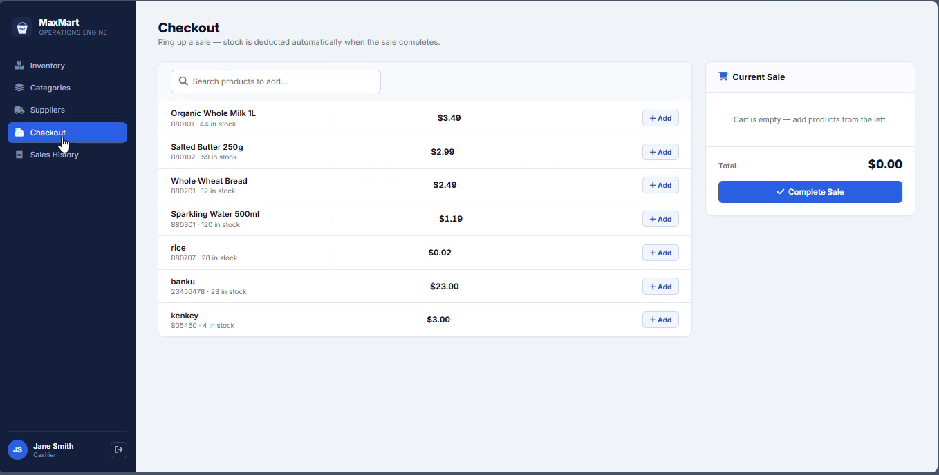
Figure 4 — Checkout tab: building a cart from live stock before completing a sale.
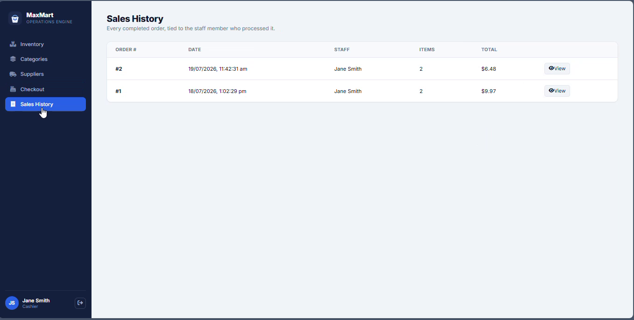
Figure 5 — Sales History showing Order #2, attributed to the signed-in staff member (Jane Smith), immediately after checkout.
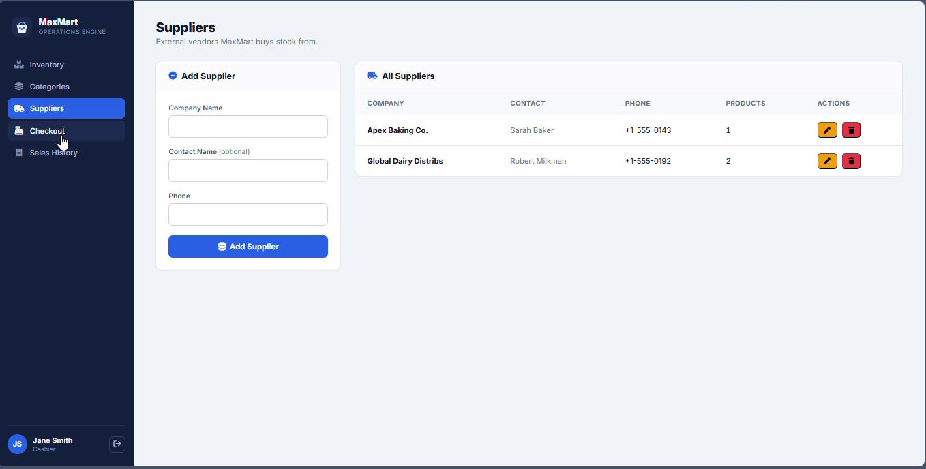
Figure 6 — Suppliers tab, fully CRUD-managed rather than hardcoded.

8.8 Security & Improvement Notes
Two gaps flagged in the original submission — no login, and no web-based order entry — are now closed. The remaining production-readiness improvements identified are:
- The database connection still uses the root MySQL account with no password; a dedicated least-privilege application user should be created before any real deployment.
- Both Manager and Cashier roles are recorded and checked at login, but the API does not yet differentiate permissions between them — a signed-in Cashier can currently delete products or suppliers, actions a real deployment would likely restrict to Managers only.
- Login has no rate-limiting or lockout after repeated failed attempts, so brute-force protection is a good next addition.
- The session cookie's secure flag is currently false to work over plain HTTP on localhost; it should be switched to true once the site is served over HTTPS.

Conclusion
This assignment took MaxMart Supermarket's stock-and-till problem through all eight phases of the database development lifecycle: a written requirements narrative, entity and attribute identification, fully typed integrity constraints, an isolated entity-type diagram, a conceptual ER model with cardinalities and participation constraints, a logical relational schema with referential integrity arrows, a physical MySQL implementation populated with representative data, and a working PHP/JavaScript dashboard.
The web layer now reaches every table in the schema rather than just the product catalogue: staff sign in against the staff table before touching any data, categories and suppliers are fully manageable rather than hardcoded, and completing a sale in the Checkout tab is a real transaction against ORDERS and ORDER_ITEMS that also decrements stock — the business process the whole schema was designed around in Phase 1, not just its supporting catalogue data. What remains, documented honestly in Section 8.8 rather than glossed over, is permission differentiation between the Manager and Cashier roles the schema already distinguishes, and the usual pre-production hardening (a least-privilege database user, login rate-limiting, and HTTPS).

